# **Name: Abdurrahman Qureshi**

# **Roll No: 210451**

Practical No: 1

1. **Print the version of Python**

**CODE:**

import sys  
  
print("Python Version: " , sys.version)

**OUTPUT:**

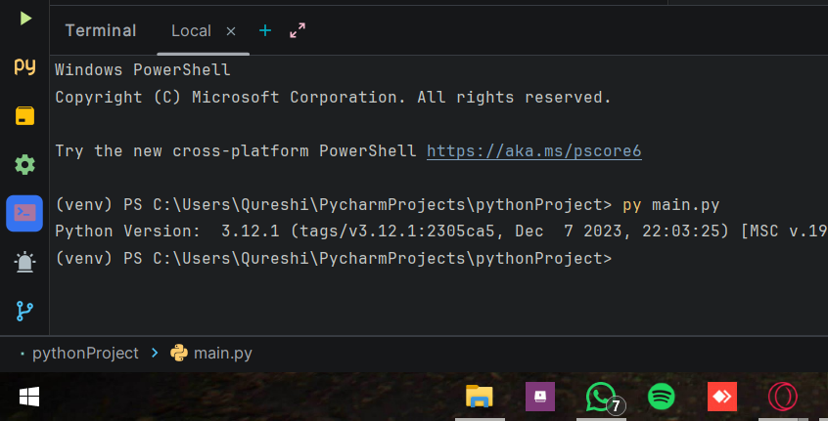

1. **Write steps to be followed to load Python interpreter in windows.**

**ANS:**

**Download Python Installer:**

Visit the official Python website, go to the "Downloads" section, and download the Python installer for Windows (make sure to choose the correct version, 32-bit or 64-bit).

**Run the Installer:**

Locate the downloaded installer file (usually named **python-3.x.x.exe**) and double-click to run it. The installer will guide you through the setup process.

**Customize Installation (Optional):**

In the installer, you can choose to customize the installation. It is recommended to check the option "Add Python to PATH" to make the Python interpreter globally accessible.

·**Complete Installation:**

Click on the "Install Now" button to start the installation. Once finished, you'll see a screen saying "Setup was successful." Python is now installed on your Windows system.

**Verify Installation:**

Open the Command Prompt or PowerShell and type **python** or **python --version**. If the installation was successful, you'll see the Python interpreter prompt or version information. You can start entering Python commands directly in the console.